Technical Design Specification

Tourist Content Management System
for
Good Guide

Doc Revision 1.12



Nucleo Technologies

4 Wafra Close
Melkbosstrand
7441
South Africa

 P.O. Box 50218, West Beach, 7449
 + 082 892 6754
 louis@nucleo.co.za | ☑ www.nucleo.co.za

1. Revision History 3
2. High-level Design 4
3. Application Architecture 5
3.1. Overview 5
3.2. Plug-in Components 7
3.3. Event Broker 7
4. Implementation 9
4.1. Database 9
4.1.1. Administration 9
4.1.2. Content 10
4.1.3. Channel content 11
4.1.4. Routes 12
4.1.5. Destinations 15
4.1.6. Database Table Definition 16
4.2. Events 22
4.3. Application Events 23
4.4. Control Events 24
4.5. Event Interaction 25
4.5.1. GpsPositionEvent 25
4.5.2. NavigatorAnnouncementEvent 26
4.5.3. Region Events 26
4.6. Components 27
4.6.1. Integration Layer 27
4.6.2. GpsAdapter Component 31
4.6.3. RegionTrigger Component 32
4.6.4. TripRecorder Component 34
4.6.5. User Interface 36
4.6.6. Navigator Component 36
4.6.7. ContentManager 38
4.6.8. Media Access 41

- Revision History
Date | Revision | Notes
2008-08-12 | 1.0 | - Created document
2008-08-16 | 1.1
2008-08-21 | 1.2
2008-08-26 | 1.3 | Added mobile database design
2008-08-26 | 1.4 | - Removed Theme table  - Removed RentalTheme table  - Removed ThemeRoute table  - Added DestinationType table  - Added DestinationClassification table  - Added RegionTrigger hit test concept
2008-08-28 | 1.5 | - Added Media Access component functional requirements  - Added Content Manager functional requirements  - Added Navigator functional requirements
2008-08-31 | 1.6 | - Updated ChannelContent table  - Updated GpsRegion table  - Added MasterArea table  - Added Theme table  - Added RegionMasterArea table  - Added RegionTheme table  - Added DestinationMasterArea table  - Added DestinationTheme table  - Deleted PictureContent table
2008-09-06 | 1.7 | - Added ResetOnEnter to GpsRegiontable
2008-09-09 | 1.8 | - Updated ChannelContent table
2008-09-16 | 1.9 | - Updated ChannelContent table  - Updated ContentItem table  - Deleted Channel table  - Updated GpsRegion table  - Deleted RegionTheme table  - Delete RegionMasterArea table
2008-09-17 | 1.10 | - Updated GpsRegion table  - Updated ContentItem table  - Added Channel table  - Added ChannelGroup table
2008-09-17 | 1.11 | - Updated ChannelContent, ContentItem relation
2008-11-18 | 1.12 | - Defined route management

- High-level Design
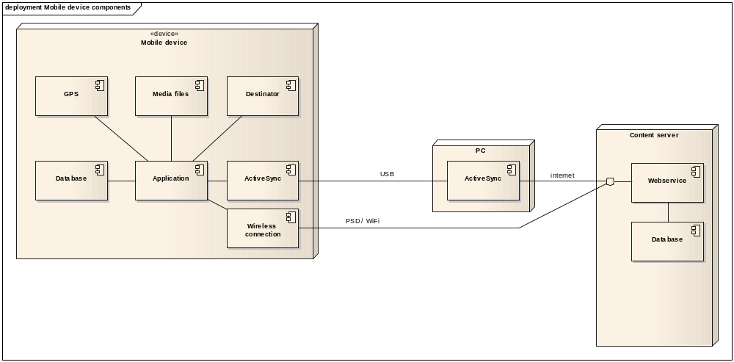
Element | Notes
Database | All application data (except content files) will reside in the mobile database. The data will be exchanged between the mobile database and the GoodGuide server by means of webservices.
Webservice | The server-based webservices component provides the interface through which the mobile device will download and upload data.
ActiveSync | ActiveSync provides a TCP/IP-enabled network segment between the mobile device and the PC in the absence of a wireless connection between the device and the internet.
Database | The server-based database will provide the data store for content, routes, user, destinations. etc. This database will also serve the website.
Wireless connection | For a device with wireless capabilities, the wireless connection will provide TCP/IP connectivity over packet-switched data networks (GPRS/EDGE/3G/HSDPA) or 802.11x (WiFi & WiMax).
Application | The application will provide the user interface and an integration layer. The integration layer will enable the integration with the database, GPS, content and Destinator.
Media files | The media content that will be presented to the user will reside on an SD card in encrypted media files. A new set of media files can be loaded onto the device at any point. Typically this will happen at a retail outlet.
GPS | The GPS may be built into the device or external by means of a Bluetooth connection.
Destinator | The Destinator module will provide routeing and map display functionality.
ActiveSync | ActiveSync provides a TCP/IP bridge between the USB-based network segment (between the internet-enabled PC and the mobile device) and the internet connection.

- Application Architecture
  - Overview
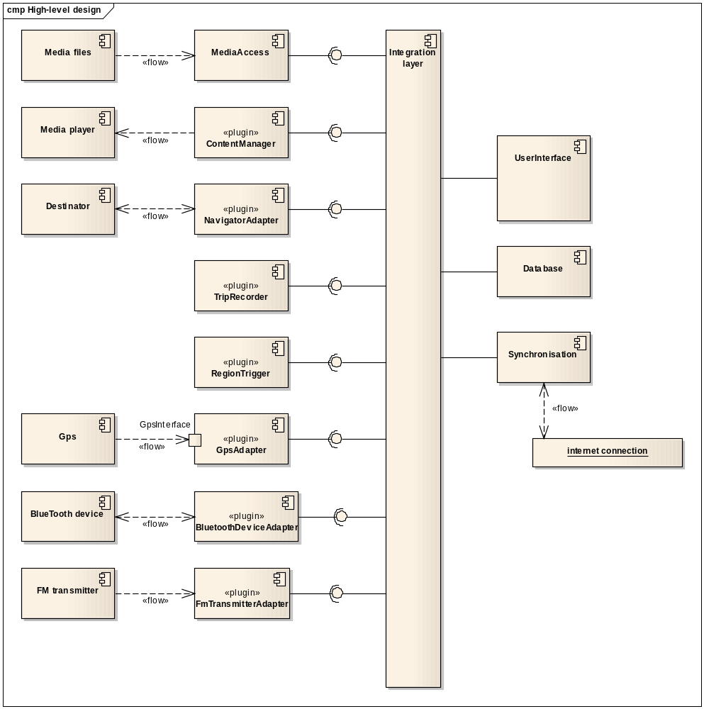
Element | Notes
Integration layer | The integration layer will:  - Provide the ability to load plugin components at runtime  - Act as event broker between components  - Provide a handle to the database to all components
GpsAdapter | The GpsAdapter will have the following characteristics:  - Conform to the plugin interface specification to be loadable at runtime.  - It will be a publisher of the GpsPositionEvent  - It will provide an interface to a GPS device. Different GpsAdapter plugins will support different types of GPS e,g, internal or external  - It will provide methods for controlling the behaviour of the component  - It will initialise, deinitialise and control the associated physical GPS device
TripRecorder | The TripRecorder will have the following characteristics:  - Conform to the plugin interface specification to be loadable at runtime.  - It will be responsible for logging GPS position data to database or file in order to record a trip.  - It will be responsible for replaying a pre-recorded trip  - In recording mode, it will be a subscriber to the GpsPositionEvent  - In playback mode, it will be a publisher of the GpsPositionEvent
Database | The mobile database will provide the primary means to store inforamtion (except content) relevant to the application. Data will be synced between the server database and the mobile database by means of webservices.
UserInterface | The user interface will:  - provide all screens with which the user interacts with the application  - build menus, etc from data stored in the database  - display relevant data to the user  - provide the ability to display content e.g. videos and photos  - provide the abiliaty to switch to and back from the Destinastor display
NavigatorAdapter | The NavigatorAdapter will have the following characteristics:  - Conform to the plugin interface specification to be loadable at runtime.  - Provide the interface to the navigator component. Specific NavigatorAdapter implementations may support different navigator components. The first implementation will support the Destinator navigator component  - It will provide methods for controlling the behaviour of the navigator  - It will initialise, deinitialise and control the associated navigator  - It will be a subscriber to the GpsPositionEvent  - It will be a publisher of the NavigatorAnnouncementEvent
ContentManager | The ContentManager component will:  - Conform to the plugin interface specification to be loadable at runtime.  - It will be a subscriber to the RegionEnterEvent, RegionExitEvent and ActiveRegionListEvent in order to trigger location-relevant content  - It will be a subscriber to the NavigatorAnnouncementEvent in order to mute, pause or resume the playing of content.  - It will implement the rules regarding triggering of content, depending on heading, speed, location, other conrent that is playing, etc.  - The user can also trigger content  - Content triggering is dependent on the mode of operation: Navigator only or Navigator + GoodGuide
RegionTrigger | The region trigger will have the following characteristics:  - Conform to the plugin interface specification to be loadable at runtime.  - It will be a subscriber to the GpsPositionEvent event  - It will be a publisher of the RegionEnterEvent, RegionExitEvent and ActiveRegionListEvent events  - It will process GPS fix positions, perform the necessary region calculations and signal when the fix position has entered of left a region.  - It will load the region definitions from the database
Media files | The content files shall reside on an SD card in secure format
Gps | The GPS device may be an internal device or external device. The associated GpsAdapter plugin component will control the physical device.
Synchronisation | The synchronisation component will be responsible for:  - establishing the connection with the server  - synchronising data between the mobile and server database
MediaAccess | The MediaAccess component will provide the ability to:  - load a secure media content file and provide it in normal format internally to the rest of the components for use.  - save new media files in a secure manner  - The ContentManager component would typically use this component for playing videos and sound files.
BluetoothDeviceAdapter | The BluetoothDeviceAdapter will allow connection with other devices  It will also allow position trigger events while indoors e.g. if a BlueTooth device with ID number X34567 is located, we know this is outside Pick n Pay at the Waterfront.  The BluetoothAdapter will have the following characteristics:  - Conform to the plugin interface specification to be loadable at runtime.  - It will be a publisher of the DestinationPositionEvent  - It will provide an interface to a BlueTooth device.  - It will provide methods for controlling the behaviour of the component  - It will initialise, deinitialise and control the associated physical Bluetooth device
FmTransmitterAdapter | The FmTransmitterAdapter will allow connection an FM transmitter  The FmTransmitterAdapter will have the following characteristics:  - Conform to the plugin interface specification to be loadable at runtime.  - It will provide methods for controlling the behaviour of the component  - It will initialise, deinitialise and control the associated physical FM transmitter device
Media player | The ContentManager will use the WIndows Mobile Media Player to deliver sound and video content.

  - Plug-in Components
All plug-in components as indicated in the architecture diagram will be loaded dynamically at startup. The benefits of this are:
- The application will be easily extensible by deploying new components.
- Existing components can easily be updated by deploying only the new version of the plug-in
- Provide clear boundaries between the development and testing initiatives
- New event publishers and subscribers can easily be added or removed without having to alter any other part of the application. The event subscribers and publishers are ‘discovered’ when the plug-ins are loaded.

  - Event Broker
Interaction between plug-in software components are by means of events that are passed between them. An Event Broker in the integration layer is responsible for the distribution of events between components. Event handling is on a publisher-subscriber basis. The figure below illustrates this concept.

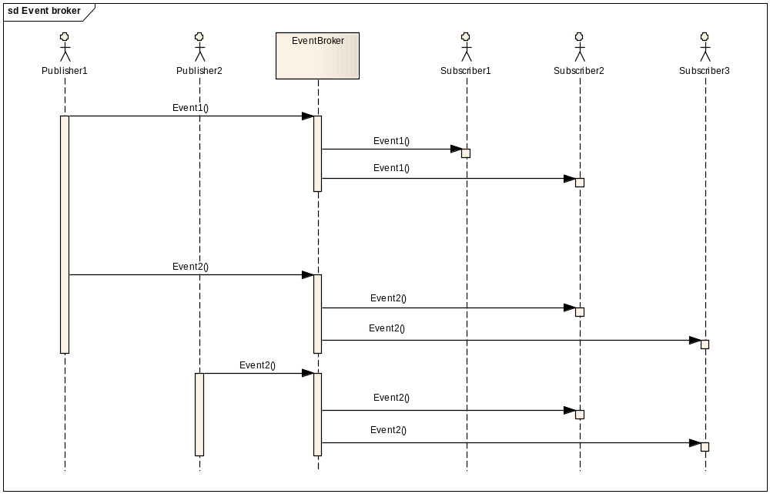

The major advantages of this architecture are:
- Being able to more loosely couple all components and not having any component physically dependent of the existence of another.
- At startup, the event broker will ‘discover’ all event publishers and subscribers. Therefore, by simply defining a component as a subscriber to a particular event, the event will automatically be broadcast to that component when it is published by any particular component.
- More than one component can publish a particular event and more one component can subscribe to a particular event. The benefit of this is that components can be interchanged without affecting operation.
- Provide clear boundaries between the development and testing initiatives
- Implementation
  - Database
The mobile device database is defined in this section.

    - Administration
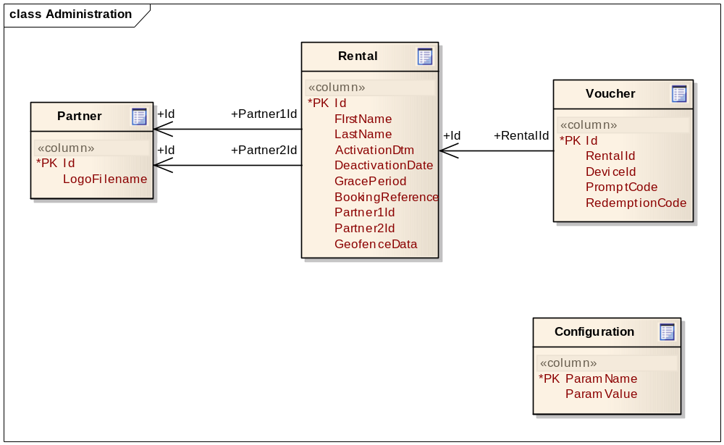

    - Content
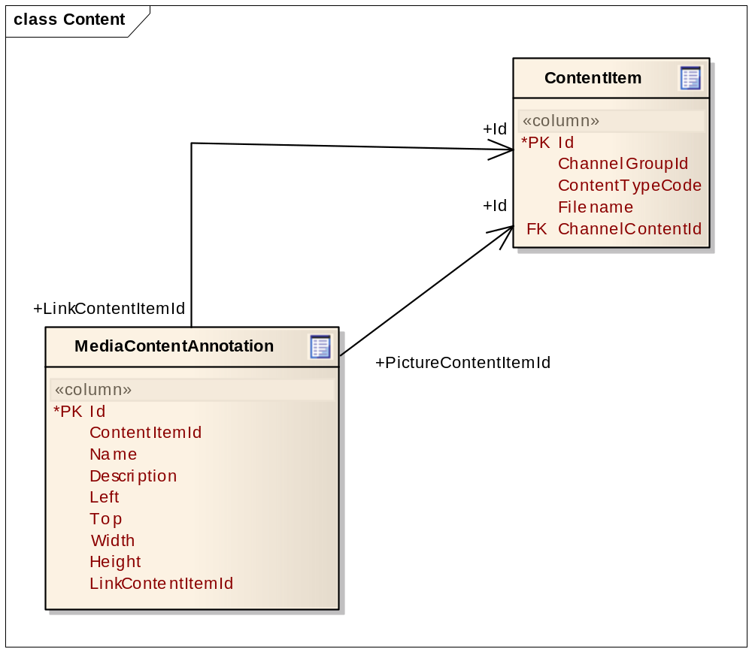

    - Channel content
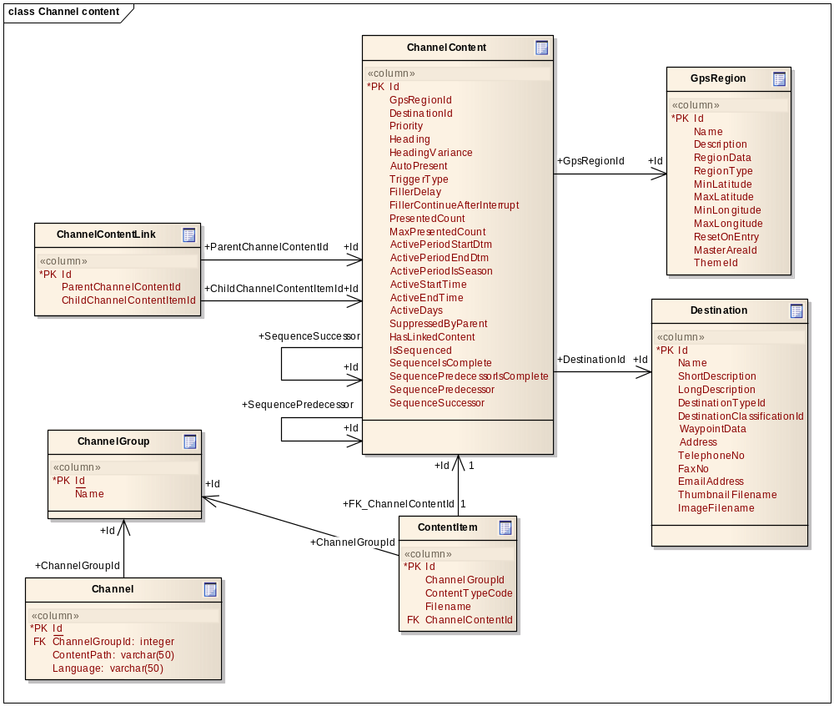

    - Routes
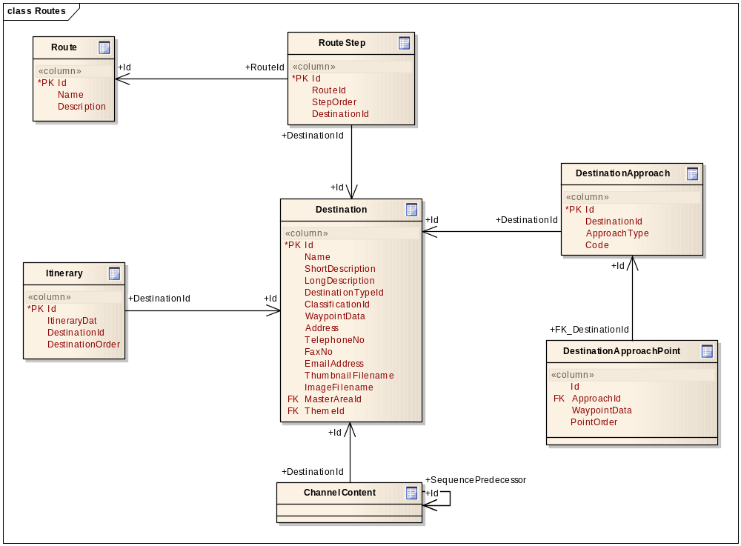

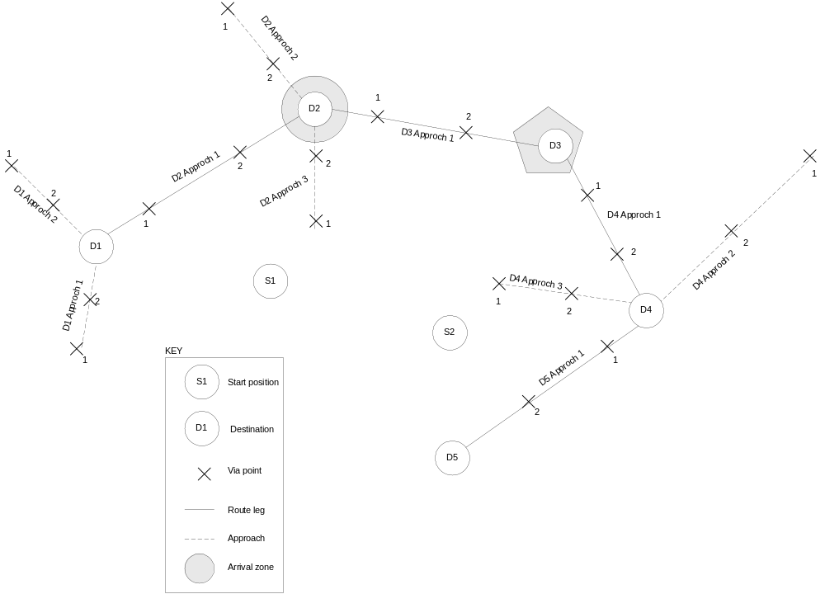

Refer to the above diagram of how routes are managed.

The requirements are as follows:
- Routes are defined by any number of destinations in a particular order. These destinations are significant points of interest and may have associated content, etc. The goal is to guide the user along the route via these destinations.
- The application should be able to route the user from one destination to the next along a defined route and not necessarliy using the shortest distance / shortest time method.
- The user may be guided from his current position onto the route by routing him to the closest of a number of defined route entry points.
- Guide the user to a stand-alone destination (not part of a route). The user may need to be guided to the stand-alone destination along a particular route e.g. specific gates.

In order to satisfy the requirements and retain a large degree of flexibility, we define the following concepts:

Route | Collection of destinations in a particular order (shown in the diagram)
Destination | Point of interest. Each destination will have an associated geographical position (in lat/long) and an arrival zone.
Arrival zone | An arrival zone is deemed to be the area around a destination that, if the arrival zone is entered, the user is deemed to have reached the destination. From here the user is guided to the next destination. Arrival zones are defined per destination and can be a circular or polygon region
Start point | The user’s current destination from where he will be guided onto the route
Approach | A destination may have multiple approaches. An approach is a collection of via points defined in a particular order. When the user is guided to a destination, he is always guided via the via points on a one-by-one basis. This ensures that the user stays along a predetermine path between route destinations. When the user reaches a via point, the application will guide the user to the next.
Via point | A via point is an intermediate destination along the approach to the next destination. Each via point has a geographical location (lat/long) and an arrival zone. Each via point in the approach is numbered according to order in which the user will be guided. The first via point is always numbered 1.

By combining the above concepts we achieve the following:
- Every destination, whether part of a route or stand-alone has any number of approaches. These approaches define the intermediate points along which the user will be guided to the destination, whether coming from an arbitrary location or a previous destination along a route.
- By numbering the via points, the application can determine, given an arbitrary start position, which the closest first via point is for any of the route destinations and approaches. It will simply search the database for all via points numbered 1, for all approaches, for all destinations, for the selected route. This will guide the user to the closest route entry point.
- Alternatively, any via point on any of the destination approaches can be checked for proximity. This will guide the user to the closest via point whether it is the first one or not.

    - Destinations
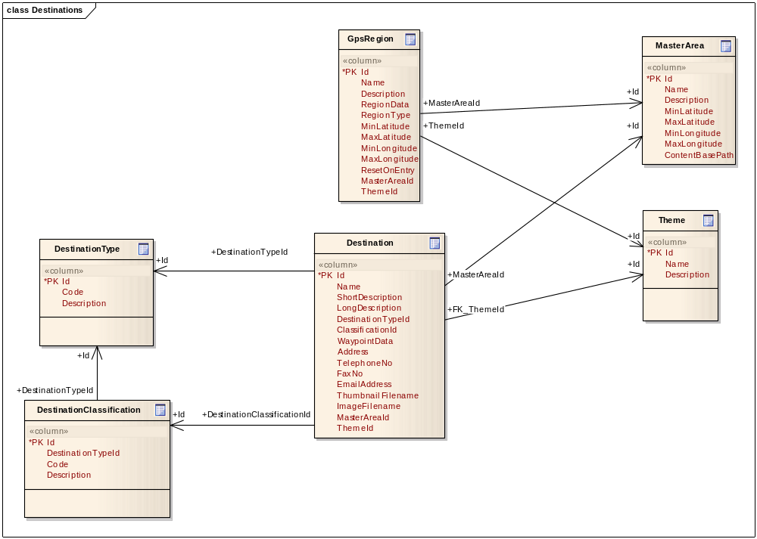

    - Database Table Definition

      - ChannelContent
This master table is used to associate a content item with a channel and optionally a region or destination. This master table is synced from the server prior to device collection.

Region-independent content may be triggered when no region-specific content is presented.

A region or destination may have many content items associated with it, especially in the case where multiple languages are supported. However, a region or destination may also have multiple content items for a single channel. This table also defines the parameters of how a content item is presented within the region.

Column | Remarks
Id | Primary key
GpsRegionId | The optional GPS region associated with the content. Region and destination are mutually exclusive.  This field is empty when defining region-independent content like stories or music.  This field will refer to a GPS region if the content is region-specific.
DestinationId | The optional destination associated with the content. Region and destination are mutually exclusive.
Priority | The priority of the content item. A lower number indicates a higher priority.
Heading | The heading constraint to trigger the content. If the content is heading independent, this field will be empty. This field will be populated if the content has to be triggered only if the custromer is travelling with the defined heading (+- HeadingVariance). Field is expressed in degrees. Applicable to region only.
HeadingVariance | The heading variance around the Heading that will constrain the content trigger. The field is expressed in degrees. Applicable to region only.
AutoPresent | This field will define whether to auto-present content or prompt first. A values of 1 indicates auto-present and 0 indicates prompt. Not applicable to destination.
TriggerType | This field indicates the trigger type. The trigger type is represented by a single character as follows:  E: Entry - The channel content is triggered when the user enters a region.  X: Exit - The channel content is triggered when the user exits a region.  W: While In - The channel content will only play while the user is in the region. If the user moves out of the region, the content will stop.  A: Anywhere - The content can play anytime. This is usually filler content.
FillerDelay | If this field is populated, the content item acts as a filler. This field is the delay (in seconds) after the end of the last content presentation at which to start the presentation of this content. Not applicable to region or destination
FillerContinueAfterInterrupt | This field indicates, for filler content, whether to continue after it was interrupted by higher priority content. If the value is 0, then another filler content item will be started. If the value is 1, the interrupted filler content is resumed. Not applicable to region or destination
PresentedCount | This field indicates the number of times the content item was presented. Not applicable to destination
MaxPresentedCount | This field indicates that maximum number of times the content item can be presented. Not applicable to destination
ActivePeriodStartDtm | The start date and time of the period in which the content item may be presented.
ActivePeriodEndDtm | The end date and time of the period in which the content item may be presented.
ActivePeriodIsSeason | Indicates that the active period is seasonal i.e. occurrs every year
ActiveStartTime | The daily start time from which the content item could be presented. If this field is empty, the content can be presented anytime after midnight. If this field is populated, the content will only be presented after the defined time.
ActiveEndTime | The daily end time to which the content item could be presented. If this field is empty, the content can be presented anytime up to midnight. If this field is populated, the content will only be presented until the defined time.
ActiveDays | This field represents the days of the week that the content item can be presented. This field is a 8-bit bitmask where each bit (from LSB) represents a day of the week. The bits (from LSB) represent:  Bit 0: Sunday  Bit 1: Monday  Bit 2: Tuesday  Bit 3: Wednesday  Bit 4: Thursday  Bit 5: Friday  Bit 6: Saturday
SuppressedByParent | This field indicates that the content item is a child content item linked to a parent content item and has been suppressed by the parent content item already having been presented. Not applicable to destination
HasLinkedContent | This field indicates that this content item is a parent content item with linked child content items. This field is included for performance purposes so to not have to query the ChannelContentLink table to determine if linked child content items exist.
IsSequenced | This indicates that the channel content is part of a sequence for the region. Application to regions only
SequenceIsComplete | Indicates that this item in the sequence has played.
SequencePredecessorIsComplete | A flag that indicates that the content's predecessor in the sequence has been delivered. It imples that this item can be played.

      - ChannelContentLink
This master table is used to define the links between parent and child channel content items. If the parent content item has been presented once, then the child content items are suppressed.
Column | Remarks
Id | Primary key
ParentChannelContentId | Reference to the parent channel content item
ChildChannelContentItemId | Reference to the linked child channel content item

      - Configuration
This table is used to store configuration details for the application and all modules. This table is never synced.
Column | Remarks
ParamName | Configuration parameter name
ParamValue | Configuration parameter value expressed as a string

      - ContentItem
This master table is used to store content definitions. This base content table contains the basic content attributes. All other content type-related tables refer to this table on a one-to-one basis. This master table is synced from the server prior to device collection.
Column | Remarks
Id | Primary key
ChannelContentId
ContentTypeCode | Identifier indicating what type of content this record represents:  - VIDEO for a video clip  - IMAGE for a static image  - S for a sound file  - MENU for a popup menu  - PROMPT for a popup text prompt
Filename | Filename of the content to be presented. Only applicable to sound, image and video content.

      - Destination
This master table holds a list of all the available destinations e.g. tourist attractions, restaurants, guest houses etc. This table is synced from the server prior to device collection.
Column | Remarks
Id | Primary key
Name | Destination name
ShortDescription | Destination short description
LongDescription | Destination long description
DestinationTypeId | Destination type
DestinationClassificationId | Destination classification
WaypointData | Destination waypoint position and radius. This field will contain:  - the waypoint position (latitude and longitude)  - radius  - radius squared  as a delimited set of values. The values are expressed as lat,long|radius|radiussquared. Latitude and longitude is expressed in decimal degrees and radius and radius-squared in nautical miles (for performance purposes).
Address | The physical address of the destination if applicable.
TelephoneNo | The telephone number associated with the destination (if applicable).
FaxNo | The fax number associated with the destination (if applicable).
EmailAddress | The email address associated with the destination (if applicable).

      - DestinationClassification
This master table holds a list of the destination classifications. This table is synced from the server prior to device collection. Destination classifications are dependent on the destination type and is used to classify the destinations within a destination type. The typical classifications for a restaurant destination type would be:
- Fine dining
- Snack
- Fast food
- Italian
etc.
Column | Remarks
Id | Primary key
DestinationTypeId | Destination type
Code | Classification code
Description | Classification description

      - DestinationType
This master table holds a list of the destination types. This table is synced from the server prior to device collection. Destination types can be restaurants, guest houses, etc.
Column | Remarks
Id | Primary key
Code | Destination type code e.g. RESTAURANT
Description | Destination type description

      - GpsRegion
This master table is used to store all GPS region definitions. This master table is synced from the server prior to device collection. Regions can be defined as a circular region or polygon region.
Column | Remarks
Id | Primary key
Name | Region name
Description | Region description
RegionData | This field contains the region type specific data.  For a circular region, this field will contain:  - the region center waypoint (latitude and longitude)  - radius  - radius squared  as a delimited set of values. The values are expressed as lat,long|radius|radiussquared. Latitude and longitude is expressed in decimal degrees and radius and radius-squared in nautical miles (for performance purposes).  For a polygon region, this field will contain an pipe-delimited, ordered list of the polygon waypoints in the following format:  lat1,long1|lat2,long2|etc.  Waypoint coordinate pairs are pipe-delimited. Waypoint latitude/longitude values are comma-delimited. The latitude and longitude values are expressed in decimal degrees.
RegionType | This field indicates the region type; circular or polygon. For a circular region, this field will contain a 'C'. For a polygon region, this field will contain a 'P'.
MinLatitude | The minimum latitude covered by the region. This is used to enhance performance of region hit detection.
MaxLatitude | The maximum latitude covered by the region. This is used to enhance performance of region hit detection.
MinLongitude | The minimum longitude covered by the region. This is used to enhance performance of region hit detection.
MaxLongitude | The maxinimum longitude covered by the region. This is used to enhance performance of region hit detection.
ResetOnEntry | This flag indicates that an application reset event will be broadcast when the region is entered. This reset event can be used to reset content delivery counters, etc. The flag is represented by a 1 for TRUE and 0 for FALSE
MasterAreaId | This field indicates the master area the region belongs to
ThemeId | This field indicates the theme the region belongs to

      - Itinerary
This table is used to store the customer's itinerary and is synced from the server prior to device collection. The itinerary is a collection of destinations associated with a particular date. The destinations can be ordered on the particular date.
Column | Remarks
Id | Primary key
ItineraryDat | The date of the particular itinerary item
DestinationId | The destination item on the itinerary
DestinationOrder | The order in which the destination item is listed for the particular day of the itinerary.

      - MasterArea
This master table is used to dimension GPS regions and destinations. Typically the application will only load the regions and destinations associated with a master area. This master table is synced from the server prior to device collection.
Column | Remarks
Id | Primary key
Name | Master area name
Description | Master area description
MinLatitude | The minimum latitude included in the master area.
MaxLatitude | The maximum latitude included in the master area.
MinLongitude | The minimum longitude included in the master area.
MaxLongitude | The maximum longitude included in the master area.

      - MediaContentAnnotation
This master table is used to store visual annotations superimposed on image and video content items. An annotation effectively becomes a button superimposed on a video or image. The annotations can optionally invoke (link to) another content item e.g. sound, menu, popup text. This master table is synced from the server prior to device collection.
Column | Remarks
Id | Primary key
ContentItemId | ContentItem that the annotation is associated with (superimposed on). Only applicable to image and video content types
Name | Name of the annotation
Description | Description of the annotation
Left | Left location coordinate where annotation is superimposed expressed in pixels
Top | Top location coordinate where annotation is superimposed expressed in pixels
Width | Width of the annotation expressed in pixels
Height | Height of the annotation expressed in pixels
LinkContentItemId | ContentItem that is invoked when the annotation is tapped on the screen

      - Partner
This master table is used to store information about the partners in the system e.g. Avis, Hertz,etc. This table is synced from the server prior to device collection.
Column | Remarks
Id | Primary key
LogoFilename | Filename of the partner logo that will be displayed

      - Rental
This table is used to store the detail of the current rental. This table will only have one record in it. This table is synced from the server prior to device collection.
Column | Remarks
Id | Primary key
FIrstName | First name of the customer to display on the welcome screen
LastName | Last name of the customer to display on the welcome screen
ActivationDtm | The date and time that the device will become active for use
DeactivationDate | The date and time that the device will start warning the customer of deactivation.
GracePeriod | The number of days after Deactivation date when the device will be finally deactivated.
BookingReference | The customer's rental booking reference number
Partner1Id | The 1st partner associated with the rental
Partner2Id | The 2nd partner associated with the rental
GeofenceData | Collection of points that define a geofenced area in which the device is active.

      - Route
This master table holds a list of all the available routes e.g. Paarl wine route, etc. This table is synced from the server prior to device collection.
Column | Remarks
Id | Primary key
Name | Route name
Description | Route description

      - Theme
This master table is used to dimension GPS regions and destinations. Typically the application will only load the regions and destinations associated with a theme. This master table is synced from the server prior to device collection.
Column | Remarks
Id | Primary key
Name | Theme name
Description | Theme description

      - Voucher
This table is used to track voucher redemptions when the customer wishes to extend the use of the device. This table starts empty at the beginning of the rental. Any vouchers that have been redeemed are synced to the server when the device is dropped off after the rental.
Column | Remarks
Id | Primary key
RentalId | The rental that this voucher redemption is associated with
DeviceId | The current device id
PromptCode | The voucher prompt code that the device generates. The prompt code is dependent on the DeviceId
RedemptionCode | The voucher redemption code that the call centre supplies based on the prompt code.

  - Events
The system will be based on an event publisher-subscriber concept. An event base class provides all the basic fields for event mangement.
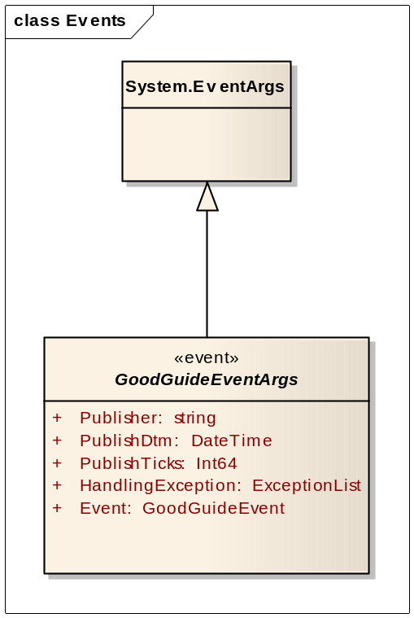
Element | Notes
GoodGuideEventArgs | This is the event class that will be used to carry all GoodGuide event payloads. All event publishers and subscribers shall use this event class.

GoodGuideEventArgs
Attribute | Data Type | Remarks
Publisher | string | This contains the name of the event publisher
PublishDtm | DateTime | Date and time of the publication
PublishTicks | Int64 | Ticks timestamp of the publication
Event | GoodGuideEvent | The event member will contain the event payload. All event payloads shall be derived from the GoodGuideEvent abstract base class.
HandlingException | ExceptionList | If the event caused an exception in the subscriber, the exception chain will be attached. This will be null for a successful event consumption

  - Application Events
Application-level events are used to exchange applicaiotn-specific information between components.
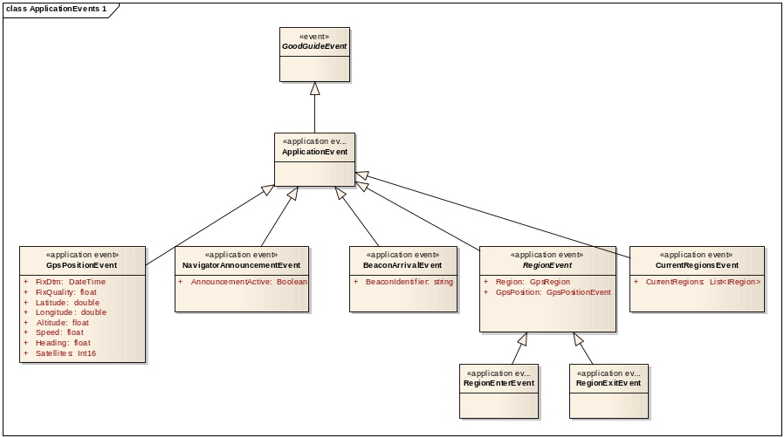
Element | Notes
GpsPositionEvent | This event is used to publish a GPS position fix to other components.
RegionEvent | This abstract event base class is the base event class for region enter and exit events.
RegionExitEvent | This event is used to publish the exit from a predefined region based on the last GPS position fix
RegionEnterEvent | This event is used to publish the entry into a predefined region based on the last GPS position fix
NavigatorAnnouncementEvent | This event is used to publish the state of the navigator announcements to the other components.
CurrentRegionsEvent | This event is used to publish a list of the predefined regions that the last GPS position is currently in.
BeaconArrivalEvent | This event is used to publish the arrival at a fixed location identified by a beacon. The beacon is identified by a BeaconIdentifier.
GoodGuideEvent | This is the abstract base class from which all GoodGuide event payloads are derived from.

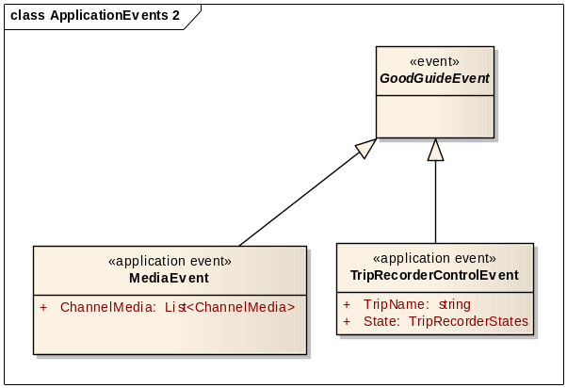
Element | Notes
GoodGuideEvent | This is the abstract base class from which all GoodGuide event payloads are derived from.
TripRecorderControlEvent | This event is used to control the recording and playback of a trip.
MediaEvent | This event isused to instruc the media manager to play content files.

  - Control Events
Control events are used to control the various components’ behaviour.
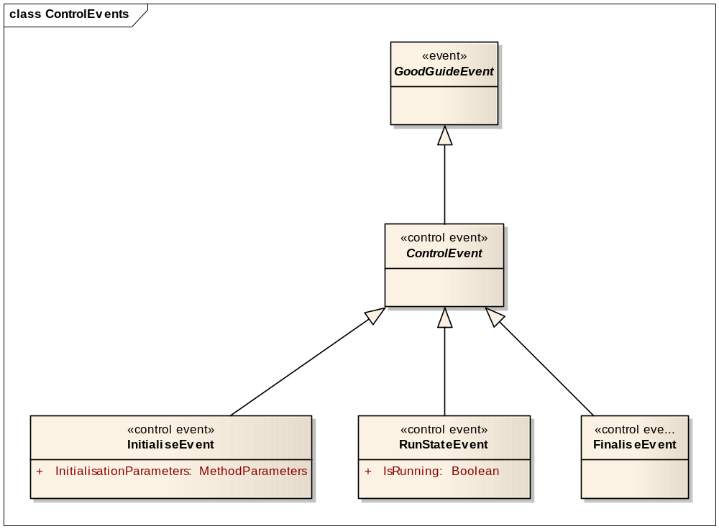
Element | Notes
GoodGuideEvent | This is the abstract base class from which all GoodGuide event payloads are derived from.
InitialiseEvent | This event is used to (re)initialise a component at runtime.
FinaliseEvent | This event is used to finalise (shot down) a component.

  - Event Interaction
The figures below indicate examples of the event flow between the components.

    - GpsPositionEvent
When the TripRecorder is in recording mode, it subscribes to the GpsPositionEvent.

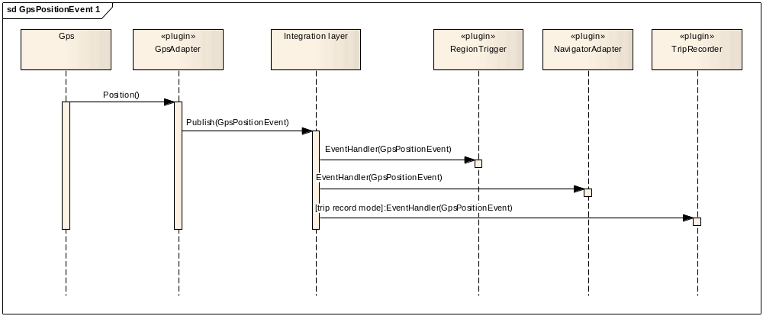

When the TripRecorder is in playback mode, it publishes the GpsPositionEvent.

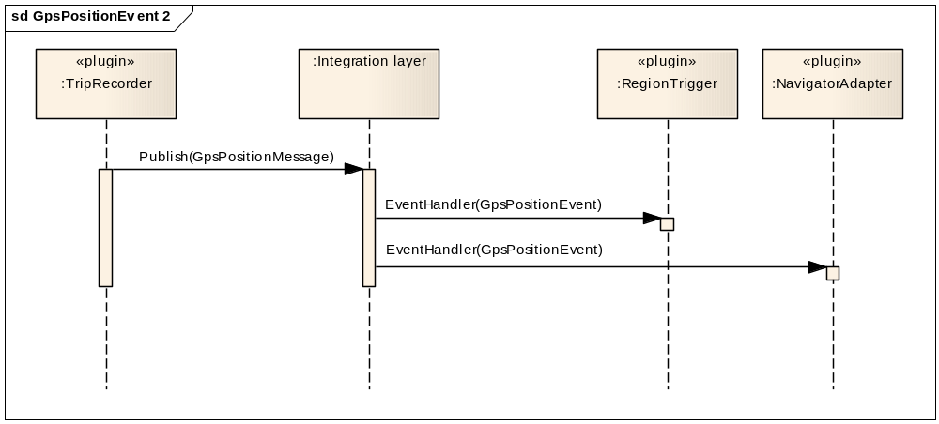

    - NavigatorAnnouncementEvent
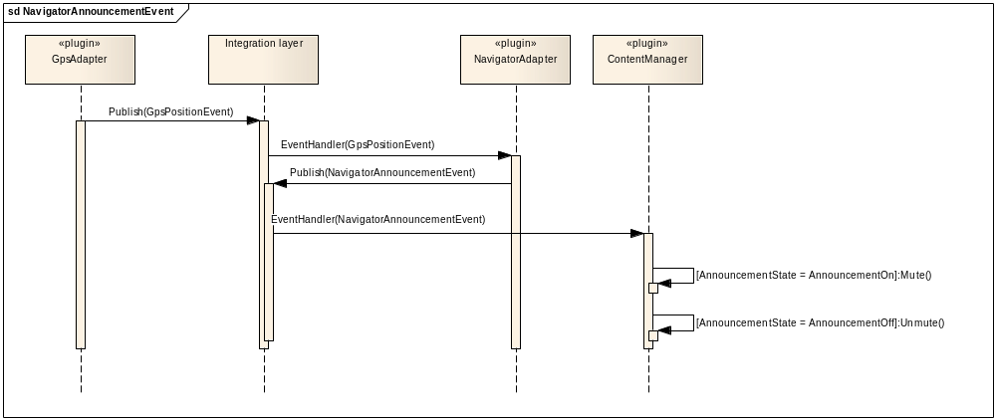

    - Region Events
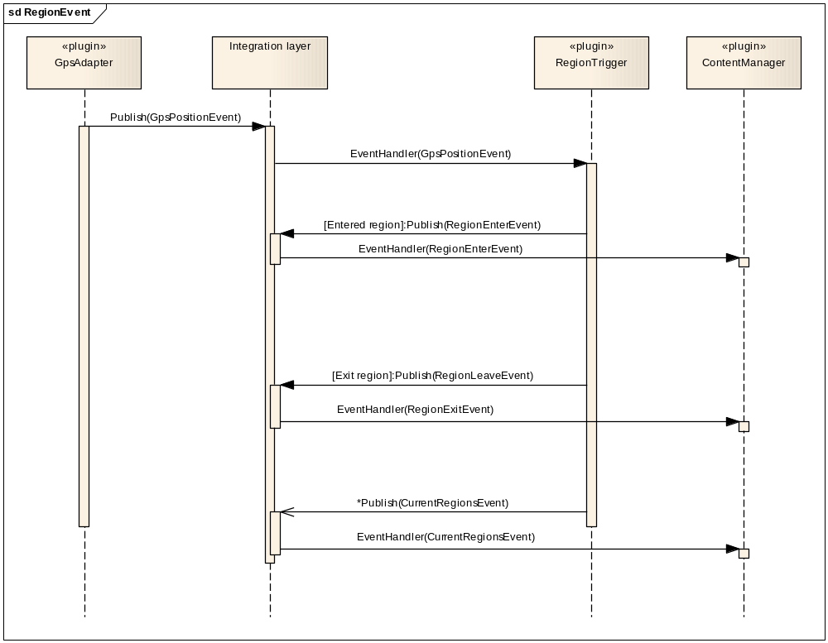

  - Components
    - Integration Layer
The Integration layer forms an integral part of the application. It loads and creates all components. The integration layer consists of 2 major subcomponents:
- PluginManager
- EventBroker

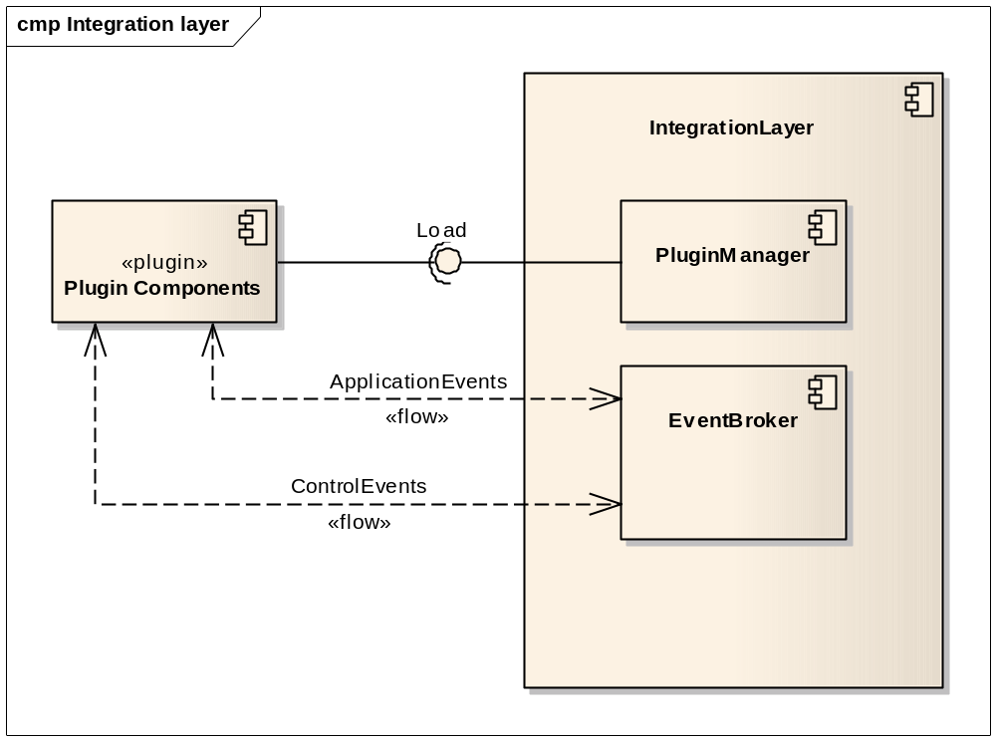
Element | Notes
IntegrationLayer | At application startup, the integration layer:  - creates the PluginManager  - creates the EventBroker  - instructs the PluginManager to load all plugins  - passes the loaded plugins to the EventBroker for event publisher and subscriber discovery
PluginManager | At application startup, the PluginManager:  - locates plugin components  - loads the plugins  - creates the plugin objects  - initialises the plugin objects  At application termination, the PluginManager deinitialises all plugin objects.
EventBroker | The EventBroker:  - inspects each plugin to discover event publishers and subscribers  - builds distribution lists for each type of event  - whenever a plugin pubslishes an event, distributes the event to all registered subscribers

      - PluginManager
As a minimum, for a component to be runtime loadable, it has to provide the following interfaces:
- Initialisation: Initialisation is used when the plugin is loaded. The initialisation interface can take a variable number of named initialissation parameters of varying types
- Finalisation: Finalisation is used whenever the plugin has to be shut down, typically at application termination

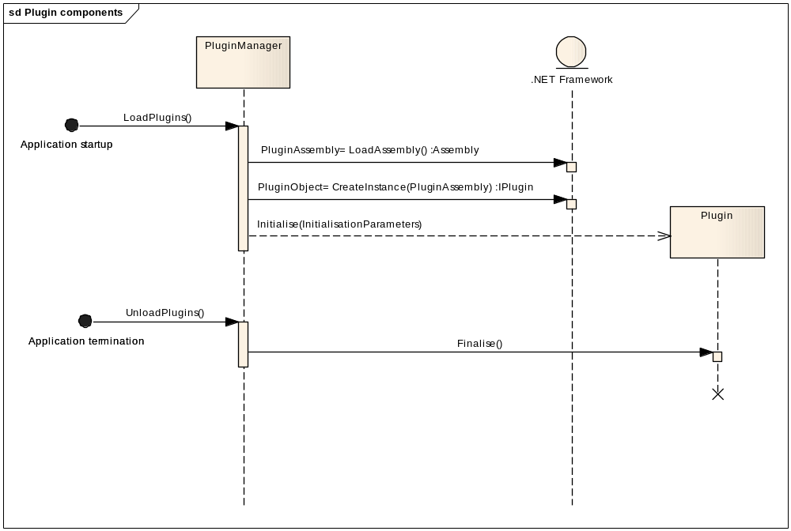

In order for a plugin component to be runtime-loadable, it has to satisfy two requirements:
- Firstly, the plugin class has to be decorated with the Plugin attribute. This identifies the class in the loaded assembly as a plugin. This attribute is defined in the Nucleo.Plugins assembly. The plugin attribute has the following mandatory string properties:
  - Name: Formal name
  - Text: Display name
  - Description: Text description of the plugin
  - Author: Author of the plugin
  - Version: Plugin version

- Secondly, the plugin class has to implement the IPlugin interface. This interface provides the initialisation and finalisation methods.

[Plugin("Name","Text","Description","Author","Version")]
public class MyPlugin : IPlugin
{
}

The plugin component interface IPlugin is located in the Nucleo.Plugins assembly and is defined as below:
public interface IPlugin
{
IPluginManager PluginManager { get; }

void Initialise(IPluginManager APluginManager,MethodParameters AParameters);
void Finalise();
}

The other type definitions are also located in the Nucleo.Plugins assembly.

      - EventBroker
The EventBroker is responsible for:
- Discovering all event publishers and subscribers
- Distributing published events to all subscribers.

In order for a component to be registered as a publisher, the EventBroker needs to discover the event publications. The discovery process relies on the event publication being identified by an event property decorated with the EventPublisher attribute. E.g.

[Plugin("Name","Text","Description","Author","Version")]
class MyPlugin : IPlugin
{
[EventPublisher(Topic)]
public event EventSubscriberDelegate ApplicationEvent;
}

Multiple events may be provided to publish different types of event.

In order for a component to be registered as a subscriber, the EventBroker needs to discover the event subscriptions. The discovery process relies on the event subscription being identified by:
- An event handler method decorated with the EventSubscrber attribute. E.g.

[Plugin("Name","Text","Description","Author","Version")]
class MyPlugin : IPlugin
{
[EventSubscriber(Topic)]
public void EventHandler(object sender,EventArgs e);
}

- The event handler method must:
  - Have 2 parameters:
    - The first of type object
    - The second of type GoodGuideEventArgs
  - Be a public, non-static method

When the EventBroker has discovered and registered all event publishers and subscribers, whenever a publishing class raises a published event of a particular topic, the EventBroker will distribute that event to all subscribers registered for the topic i.e. publishers and subscribers are connected by topic.

The EventBroker and all related classes are defined in the Nucleo.Events assembly.

    - GpsAdapter Component
The GpsAdapter plugin component shall conform to the plugin component requirements as well as act as a publisher and subscriber of events.
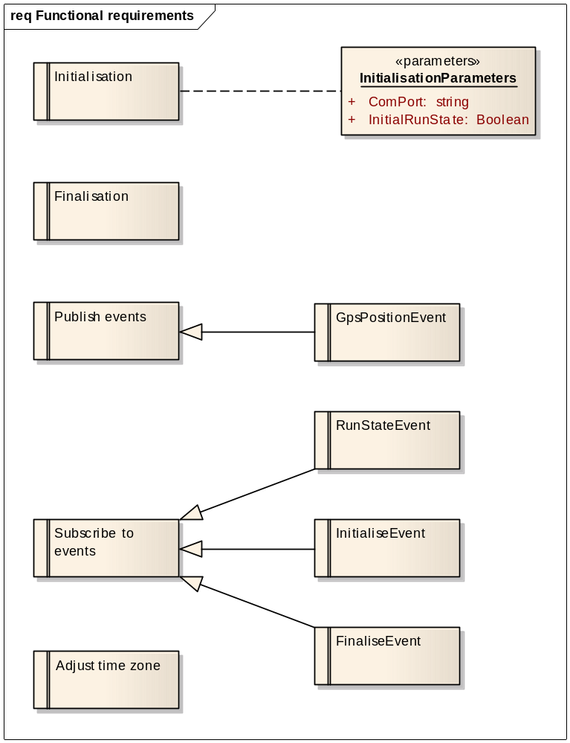
Element | Notes
Initialisation | The GpsAdapter plugin component will accept the indicated named parameters at initialisation. At initialisation, the GpsAdapter will open the indicated COM port and establish a connection with the GPS device.
Finalisation | At finalisation, the GpsAdapter will close the COM port associated with the GPS device.
GpsPositionEvent | The GpsAdapter will publish the GpsPositionEvent application event while running (RunState == true). The publication of this event will be at a frequency of 1 per second.
RunStateEvent | The GpsAdapter will subscibe to the RunStateEvent control event. This will enable the component to be started and stopped.
InitialiseEvent | The GpsAdapter will subscribe to the InitialiseEvent control event. This will enable the application to change the component's configuration parameters during runtime.
FinaliseEvent | The GpsAdapter will subscribe to the FinaliseEvent control event. This will enable the application to shut down the component during runtime. The result of this event shall be the same as the Finalisation method. The component will free all resources that was allocated.
Adjust time zone | The GpsAdapter will be able to adjust the Greenwhich time from the GPS to local time if required.

Initialisation Parameters
Attribute | Data Type | Remarks
ComPort | string | The serial communications port to which the GPS device is connected.
InitialRunState | Boolean | The default run state after initialisation. A value of true denotes a running state.

    - RegionTrigger Component
The RegionTrigger plugin component shall conform to the plugin component requirements as well as act as a publisher and subscriber of events.
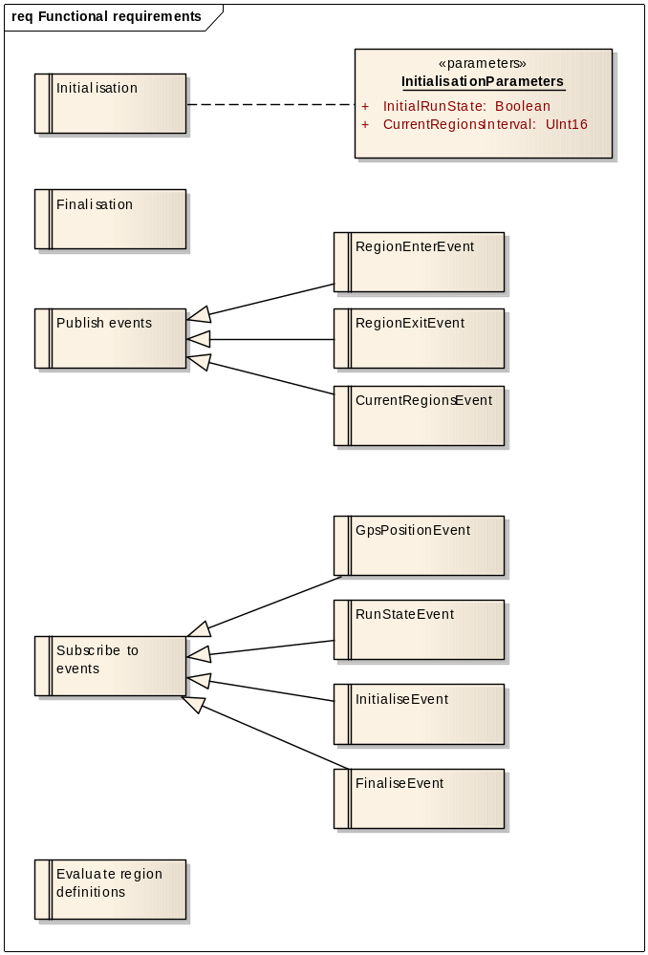

Element | Notes
Initialisation | The RegionTrigger plugin component will accept the indicated named initialisation parameters at initialisation.
GpsPositionEvent | The RegionTrigger will subscribe to the GpsPositionEvent application event while running (RunState == true).
RunStateEvent | The RegionTrigger will subscibe to the RunStateEvent control event. This will enable the component to be started and stopped.
InitialiseEvent | The RegionTrigger will subscribe to the InitialiseEvent control event. This will enable the application to change the component's configuration parameters during runtime.
FinaliseEvent | The RegionTrigger will subscribe to the FinaliseEvent control event. This will enable the application to shut down the component during runtime. The result of this event shall be the same as the Finalisation method. The component will free all resources that was allocated.
RegionEnterEvent | The RegionTrigger will publish the RegionEnterEvent application event when a predefined region is entered. The event will only be pubslihed while the component is running (RunState == true).
RegionExitEvent | The RegionTrigger will publish the RegionExitEvent application event when a predefined region is left. The event will only be pubslihed while the component is running (RunState == true).
CurrentRegionsEvent | The RegionTrigger will publish the CurrentRegionsEvent application event at a configurable frequency. The event will only be pubslihed while the component is running (RunState == true).
Evaluate region definitions | On receipt of each GpsPositionEvent, the RegionTrigger will:  - evaluate the predefined region rules as read from the database  - determine if a new region has been entered. If so, publish the RegionEnterEvent application event. The entered region then becomes a 'current' region. Regions may overlap and therefore can multiple regions be current.  - determine if a current region has been left. If so, publish the RegionExitEvent application event.  - at an interval defined by the CurrentRegionsInterval configuration parameter, publish the CurrentRegionsEvent application event. This event will have a list of all regions that are current, based on the last received GpsPositionEvent.

Initialisation Parameters
Attribute | Data Type | Remarks
InitialRunState | Boolean | The default run state after initialisation. A value of true denotes a running state.
CurrentRegionsInterval | UInt16 | The interval, expressed in seconds, between publicstions of the CurrentRegionsEvent.

To enhance the RegionTrigger’s GPS point hit test performance:
- The regions will be read from the database and cached in memory
- The hit test will follow a two-phase approach. The mathematics to determine a GPS position hit inside a region could potentially be fairly complex, especially for a polygon region. It is also unnecessarily repeated for each GPS point. In order to enhance performance, the hit test will perform a first-order rectangular bounding region check. The bounding region of a region under test is illustrated below.
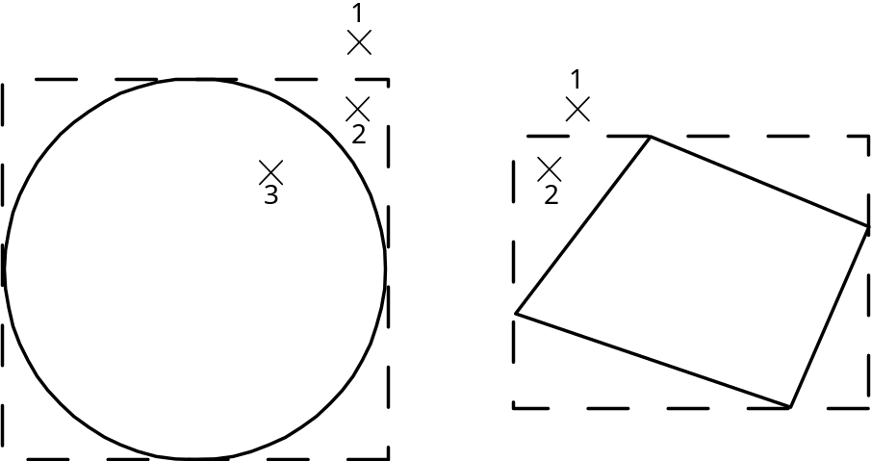

The bounding region is defined by the smallest rectangle around the region. This is easily calculated for the circular and polygon regions. The bounding region hit test is a simple ‘smaller than/greater than’ test against the GPS position and is very efficient. If the GPS point falls outside the bounding region (point 1), the region is not hit and no further hit test is done on the region. If the GPS point falls inside the bounding region, the second order, region-specific hit test calculations are performed. At this point the GPS point may fall outside the region (point 2) or inside the region (point 3). The benefit of this approach is that the more complex region-specific hit test calculations are only done when required and not with each GPS point.

    - TripRecorder Component
The TripRecorder plugin component shall conform to the plugin component requirements as well as act as a publisher and subscriber of events.
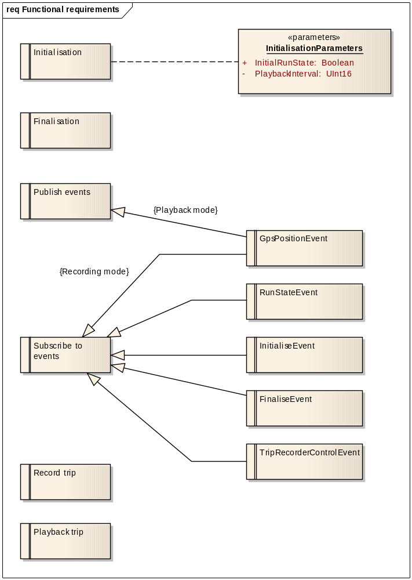

Element | Notes
Initialisation | The TripRecorder plugin component will accept the indicated named initialisation parameters at initialisation.
GpsPositionEvent | In trip playback mode, the TripRecorder will publish the GpsPositionEvent at the configurable interval. The playback can be controlled by means of the TripRecorderEvent events.  In trip recording mode, the TripRecorder will subscribe to the GpsPositionEvent.
RunStateEvent | The TripRecorder will subscibe to the RunStateEvent control event. This will enable the component to be started and stopped.
InitialiseEvent | The TripRecorder will subscribe to the InitialiseEvent control event. This will enable the application to change the component's configuration parameters during runtime.
FinaliseEvent | The TripRecorder will subscribe to the FinaliseEvent control event. This will enable the application to shut down the component during runtime. The result of this event shall be the same as the Finalisation method. The component will free all resources that was allocated.
TripRecorderControlEvent | The TripRecorder will subscribe to the TripRecorderControlEvent. See state diagram.
Record trip | The TripRecorder will record a named trip to the database. Each GpsPositionEvent will be logged against the trip name.
Playback trip | The TripRecorder will be able to play back a recorded named trip. The playback can be paused, resumed and stopped. The default playback speed is 1 second per recorded position. The TripRecorder will be able to play back the trip at a different speed, based on the configuration parameter.

Initialisation Parameters
Attribute | Data Type | Remarks
InitialRunState | Boolean | The default run state after initialisation. A value of true denotes a running state.
PlaybackInterval | UInt16 | The interval, expressed in milliseconds at which a trip is replayed.

TripRecorder states
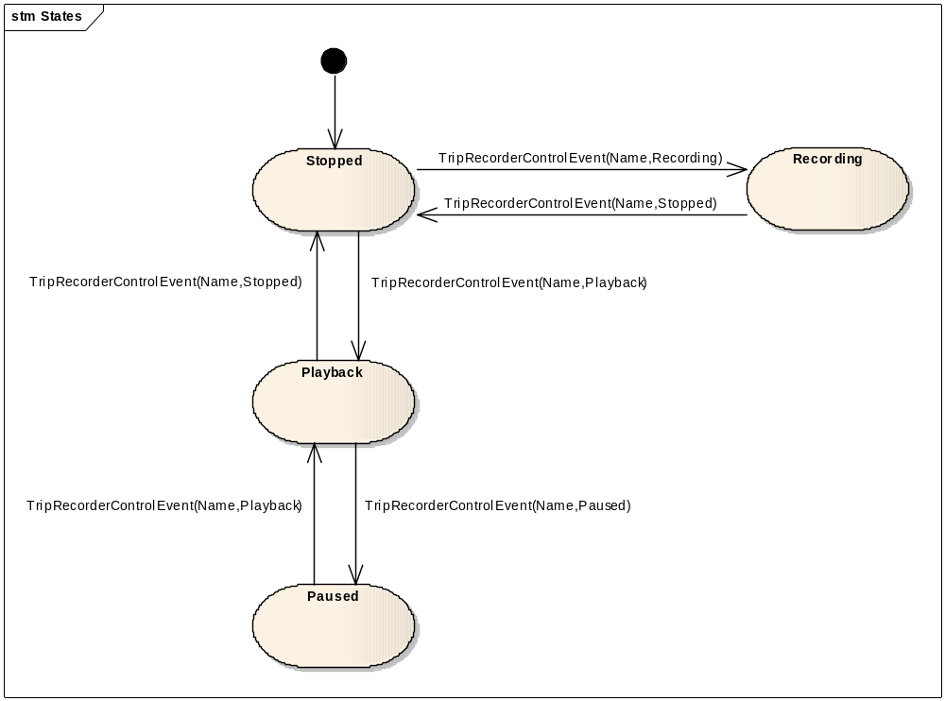

    - User Interface
To be defined

    - Navigator Component
The TripRecorder plugin component shall conform to the plugin component requirements as well as act as a publisher and subscriber of events.
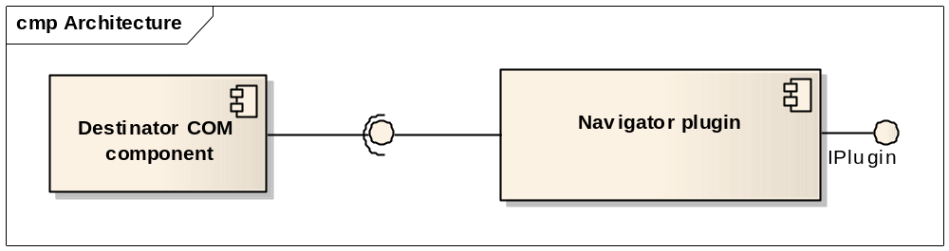
Element | Notes
Navigator plugin | The Navigator plugin component shall conform to the plugin component requirements as well as act as a publisher and subscriber of events. It will establish a connection with the Destinator component and interact with it by passing events to it.

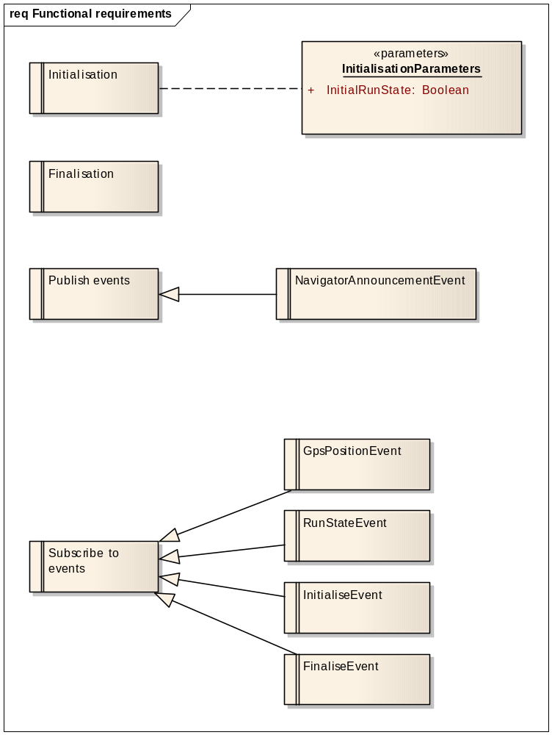
Element | Notes
Initialisation | The Navigator plugin component will accept the indicated named initialisation parameters at initialisation. It will also establish a connection to the Destinator component through a COM interface.
Finalisation | On finalisation, the Navigator component will terminate and clean up the interface to Destinator.
GpsPositionEvent | The Navigator plugin will subscribe to the GpsPositionEvent application event while running (RunState == true). It will pass the GPS position to Destinator.
RunStateEvent | The Navigator plugin will subscibe to the RunStateEvent control event. This will enable the component to be started and stopped.
InitialiseEvent | The Navigator plugin will subscribe to the InitialiseEvent control event. This will enable the application to change the component's configuration parameters during runtime.
FinaliseEvent | The Navigator plugin will subscribe to the FinaliseEvent control event. This will enable the application to shut down the component during runtime. The result of this event shall be the same as the Finalisation method. The component will free all resources that was allocated.
NavigatorAnnouncementEvent | The Navigator component will publish the NavigatorAnnouncement event prior to the Destinator announcement starting and after the Destinator announcement has ended. These events will have the AnnouncementActive field set to true and false under the respective conditions.

    - ContentManager
The ContentManager plugin component shall conform to the plugin component requirements as well as act as a publisher and subscriber of events.
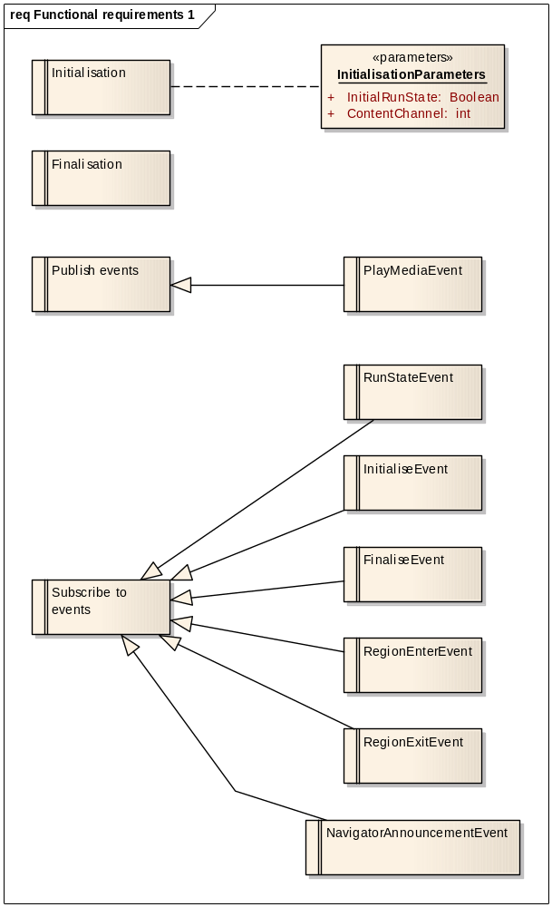
Element | Notes
Initialisation | The ContentManager plugin component will accept the indicated named parameters at initialisation. At initialisation, ContentManager will also establish a connecion with the media player.
Finalisation | At finalisation, the ContentManager will close the connection to the media player
RunStateEvent | The ContentManager will subscibe to the RunStateEvent control event. This will enable the component to be started and stopped.
RegionEnterEvent | The ContentManager will subscribe to the RegionEnterEvent application event. This will indicate to the ContentManager that a GPS region has been entered.
InitialiseEvent | The ContentManager will subscribe to the InitialiseEvent control event. This will enable the application to change the component's configuration parameters during runtime.
FinaliseEvent | The ContentManager will subscribe to the FinaliseEvent control event. This will enable the application to shut down the component during runtime. The result of this event shall be the same as the Finalisation method. The component will free all resources that was allocated.
RegionExitEvent | The ContentManager will subscribe to the RegionExitEvent application event. This will indicate to the ContentManager that a GPS region has been exited.
NavigatorAnnouncementEvent | The ContentManager will subscribe to the NavigatorAnnouncementEvent application event. If this event indicates that the navigator announcement has been activated, the ContentManager will mute the media player. If the event indicates that the navigator announcement has been deactivated, the ContentManager will unmute the media player.
PlayMediaEvent | The ContentManager will publish the PlayMediaEvent application event. This will enable the Media Manager to play the relevant content as and when required.

Initialisation Parameters
Attribute | Data Type | Remarks
InitialRunState | Boolean | The default run state after initialisation. A value of true denotes a running state.
ContentChannel | int | The content channel that the user has selected. This channel is used to determine what content to present, given a content trigger event.

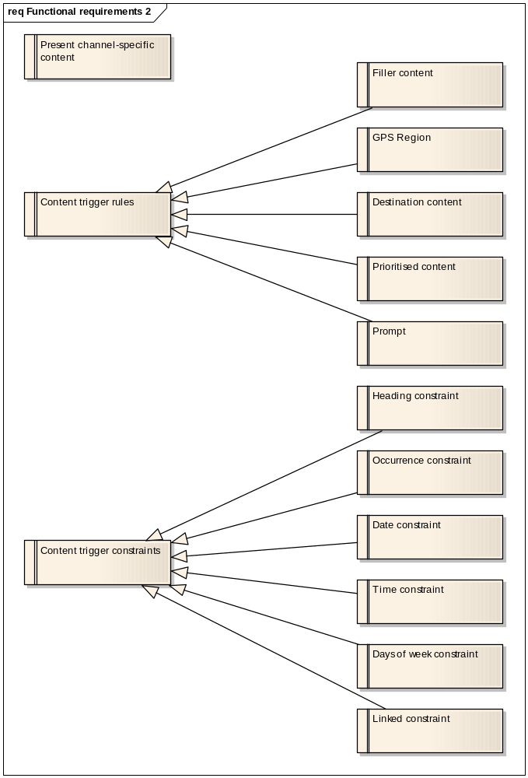
Element | Notes
Occurrence constraint | Certain content items may be constrained to only play a number of times until the occurrence counter is reset.
Date constraint | The content item may be constraint to only play between specified dates. This is typically useful in situations where certain interesting event only take place over a certain period.
Time constraint | The content item may be constraint to only play between specified times during the day.  - If the start time is undefined, the content may be delivered from 00:00:00 on the day up to the end time  - If the end time is undefined, the content may be delivered from the start time up to midnighton the partiicular day.  - Content is only delivered between start time and end time
Content trigger rules | Content can be triggered by various means. This is governed by a set of rules.
Present channel-specific content | Content is divided into multipe channels. Each channel may represent a different language or even target audience e.g. children. When content presentation is triggered, the ContentManager will present the content associated with the event and also the selected channel.  Depending on configuration, the content for all channels may be played simultaneously.
GPS Region | The presentation of channel-specific content can be triggered by the entry into a GPS region.
Destination content | Destination content is typically triggered when the user wants to know more about a particular destination. This would happen when the user is researching various destinations of interest e.g. restaurants in an interactive fashion.
Filler content | The presentation of filler content is triggered after a defined number of seconds of content inactivity. Each filler content item has a defined delay expressed in seconds. Filler content may include music, stories, etc., specific to the selected channel. When filler content is interrupted, it can optionally be resumed after the interruption.
Prioritised content | Content items are prioritised. A higher priority content item is allowed to interrupt a lower priority content item. Content will not interrupt other content with equal priority. When content of a particular priority is triggered, it will never interrupt higher priority content.
Prompt | When content is triggered, it can be presented automatically or prompt the user to confirm presentation. This is especially important in order to minimise interruptions while the user may be driving.  This is applicable to GPS region content only.
Content trigger constraints | Content triggers can have additional constraints that govern whether the content, given that the trigger occurred, will be presented or not. The trigger constraint may be applied in an overlapping fashion to achieve complex and very flexible content delivery options.
Heading constraint | A trigger may be constrained by a heading plus heading variance. This means that the content is only presented if the user entered a region in a specific direction +- a variance. This constraint is applicable to GPS region triggers only.
Days of week constraint | The content item may be constraint to only play on certain days of the week. Any combination of days of the week is possible e.g. Wednesdays and Saturdays only.
Linked constraint | When a child content item is linked to a parent content item and the parent content item has already been delivered, the child content item will be suppressed.

    - Media Access
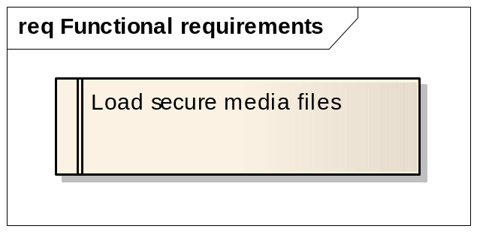
Element | Notes
Load secure media files | The media access component will have the ability to load secure media files and make it available for access by other components e.g. media player.

